<https://www.youtube.com/watch?v=YnZQJAMK6JI>

<https://github.com/justmeandopensource/kubernetes/tree/master/vagrant-provisioning>

kubectl cluster-info

kubectl get nodes

kubectl get nodes -o wide

helm repo list

helm chart repo Jenkins

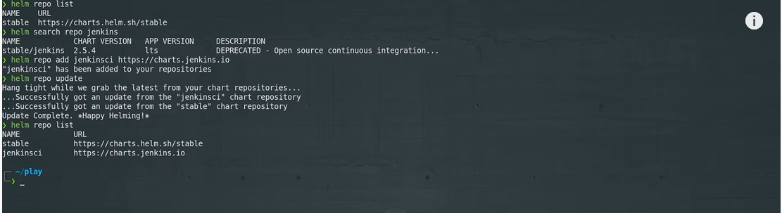

<https://www.jenkins.io/doc/book/installing/kubernetes/>

Configure Helm

Once Helm is installed and set up properly, add the Jenkins repo as follows:

$ helm repo add jenkinsci https://charts.jenkins.io

$ helm repo update

The helm charts in the Jenkins repo can be listed with the command:

$ helm search repo jenkinsci

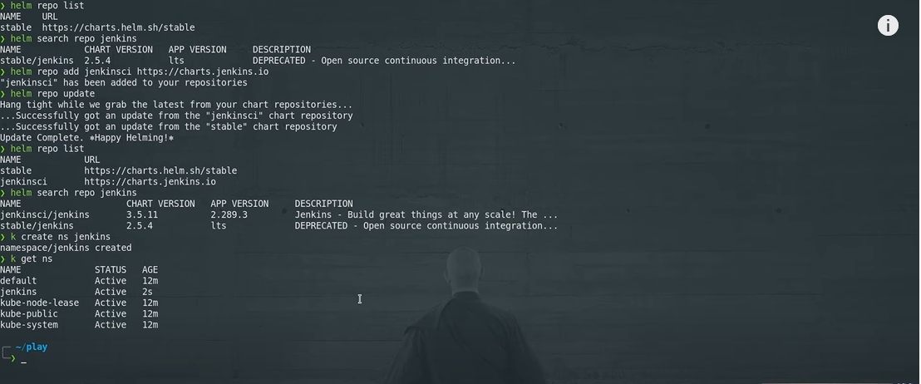

Create namespace===

